**Zonta House Refuge Association**PO Box 1276, Canning Bridge WA 6153

Phone: 08 9364 8028

Fax: 08 9364 8295

ABN: 86 136 100 855

[www.zontahouse.org.au](http://www.zontahouse.org.au)

**Statistics**

Homelessness

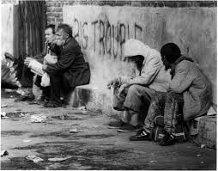

***Every night across Australia, 100,000 people are homeless…that’s 1 in 200 people***

**14,000** people Australian wide **sleep rough** every night

56% of the homeless population are Male…….44% are Female

**25%** of Australia’s homeless population is **Indigenous**

30% of Australia’s homeless population is born overseas

Every night in W.A there are 9,592 homeless people

**34%** of homelessness is due to **Family and Domestic Violence** in W.A

50% of the homeless have parents who are, or were homeless

