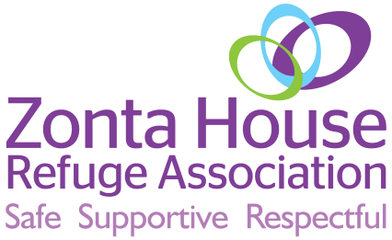
Positive Pathways
a Zonta House Women’s Refuge initiative
1/8 Yampi Way Willetton WA 6155
Phone: 1800 870 149
Email: admin@positivepathways.org.au
www.positivepathways.org,au
www.zontahouse.org.au

Positive Pathways
Referral Form
Date of Referral:
New Client: | Yes No
Referral Source: | Zonta House Women’s Refuge |  | Agency |  |  |  | Self
Agency Name:
Agency Location:
Key Worker:
Phone Number:
Email:
Comments:
Which workshops are you interested in attending? | Self Esteem & Self Confidence Yoga & Sound Therapy Keeping Safe  Building Healthy Connections Finance Skills Building Resilience  Understanding Trauma Parenting Course Art & Play Job Club
Where did you hear about Positive Pathways
Client Details:
First Name: |  | Surname:
Alias: |  | Gender:
Mobile Number: |  | Email:
Current Address:
 |  |  |  |  | Post Code:
Postal Address:
 |  |  |  |  | Post Code:
Date of Birth: |  | Age:
Do you agree to Positive Pathways contacting you using the given contact details and allow for text messages, emails and letters sent directly to you?
Yes No

Additional comments including other contact details:

Cultural Identity: | Aboriginal  Torres Strait Islander |  |  | Both  Neither

Country of Birth: |  | Year of Arrival:
Language at Home: |  | Interpreter Required? | Yes No
Culturally and Linguistically Diverse: | Yes No  If Yes, please advise details below;
Family: | Number of Children: __________________________________  Children under 18 Dependent children under 18  Children under 18 not in client’s care
Care Arrangements:

Other information:
Please fill out each section below including any additional information, which may be useful for Positive Pathways to be aware of and relevant to the workshop and any other services which may work in partnership with Positive Pathways.
Medical, Physical or disabilities:

Mental Health Issues:

Employment Status and Income Source:
Drug and/or Alcohol Issues:

Homelessness Issues:

Family and/or Domestic Violence:

Legal Issues:

Cultural Considerations:
Other Relevant Issues:

Safety Concerns? | Yes No  If yes, please advise;

Client Confidentiality
The information you provide is confidential. It will not be shared with any other party in an identifiable form without your written consent. Zonta House Women’s Refuge complies with all of the provisions of the Privacy Principles laid down in the Commonwealth Privacy Act 1988.
Zonta House Refuge Association collects statistical data statistical details about the services provided to monitor quality of service delivery, contract performance, professional accountability and to provide trends in service delivery and other social indicators. Only statistical data is collected (no personal or identifying information of any kind is divulged or included) to assure your confidentiality and anonymity.

Client Signature: |  | Date:

Please send referrals to:
Email: admin@positivepathways.org.au

OFFICE USE ONLY
 | Date | Person Responsible | Sign
Referral responded to
Confirmation sent
Database updated
Added to Spreadsheet

